A.1
CREATE DATABASE SeniorCollegeDB;
USE SeniorCollegeDB;
CREATE TABLE Student (
StudentID INT PRIMARY KEY,
StudentName VARCHAR(50), City VARCHAR(30));
CREATE TABLE Course (CourseID INT PRIMARY KEY,
CourseName VARCHAR(50), Fees DECIMAL(10,2));
CREATE TABLE Enrollment (
EnrollmentID INT PRIMARY KEY,
StudentID INT,
CourseID INT,
EnrollmentDate DATE,
FOREIGN KEY (StudentID) REFERENCES Student(StudentID),
FOREIGN KEY (CourseID) REFERENCES Course(
CourseID));
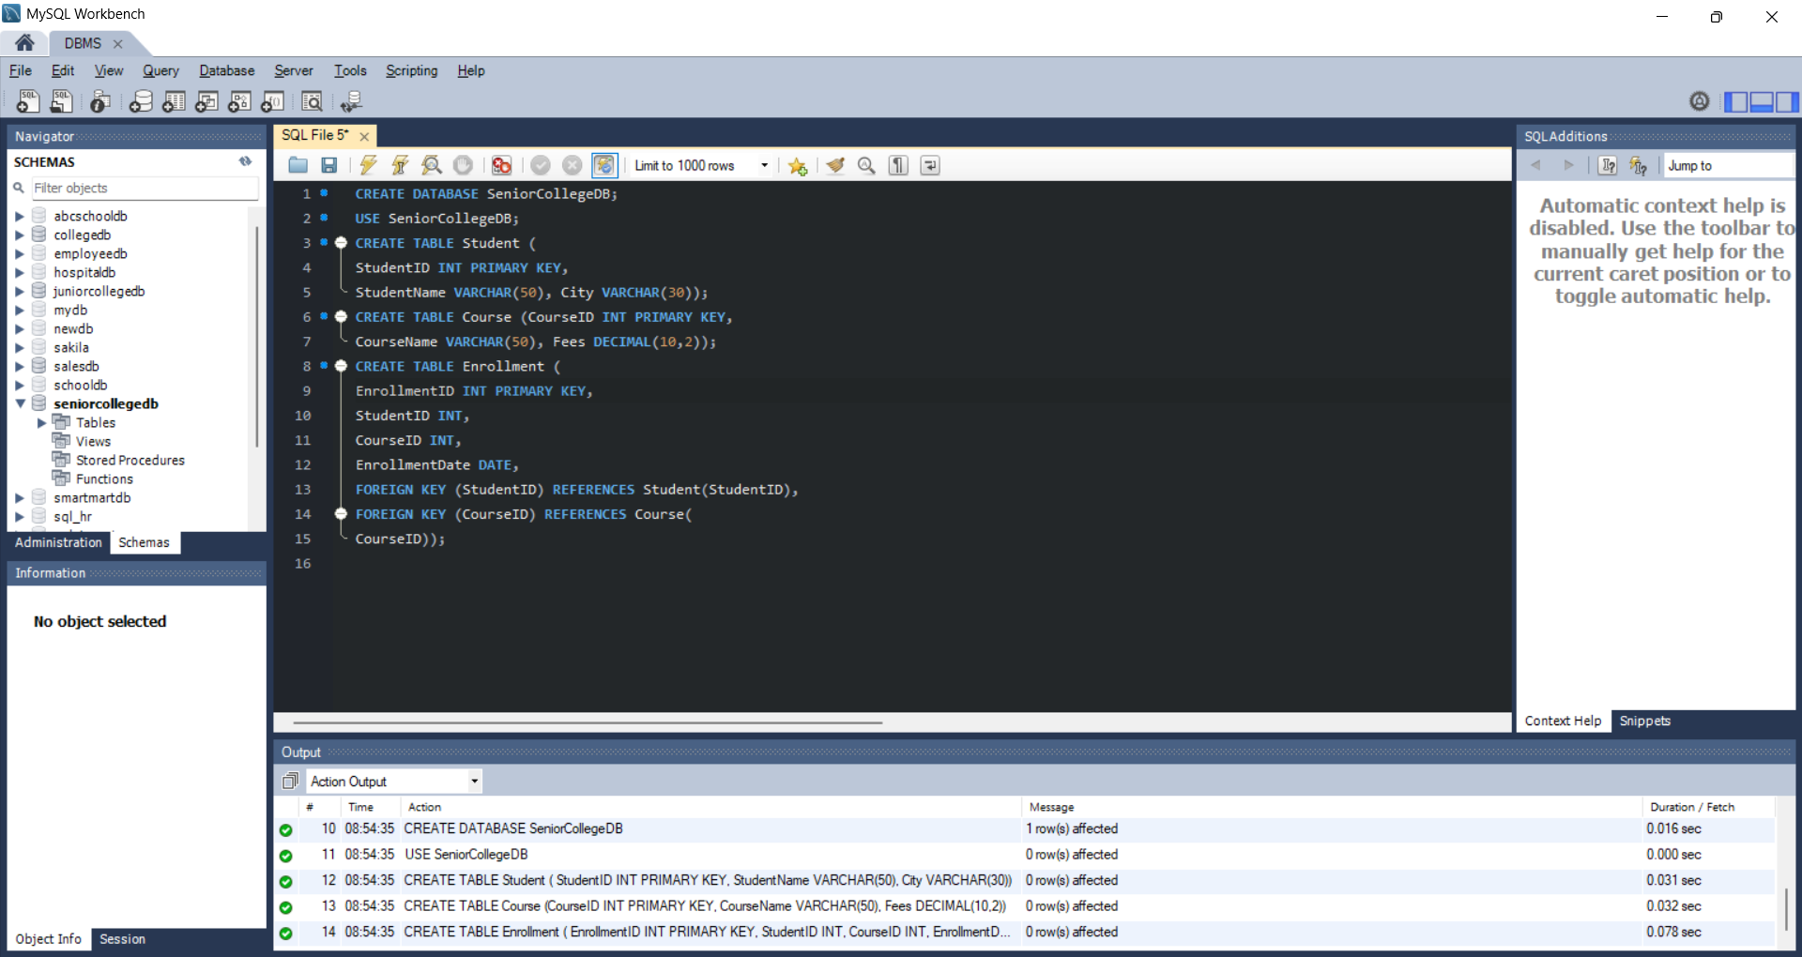

A.2
-- Insert into Student table
INSERT INTO Student VALUES
(1, 'Alice', 'NY'),
(2, 'Bob', 'LA'),
(3, 'Charlie', 'SF'),
(4, 'Dave', 'CHI'),
(5, 'Eve', 'MIA'),
(6, 'Frank', 'SEA');

-- Insert into Course table
INSERT INTO Course VALUES
(101, 'Math', 500.00),
(102, 'Science', 600.00),
(103, 'Art', 300.00),
(104, 'History', 400.00);

-- Insert into Enrollment table
INSERT INTO Enrollment VALUES
(1001, 1, 101, '2023-01-01'),
(1002, 2, 101, '2023-01-02'),
(1003, 3, 102, '2023-01-03'),
(1004, 4, 103, '2023-01-04'),
(1005, 5, 103, '2023-01-05');
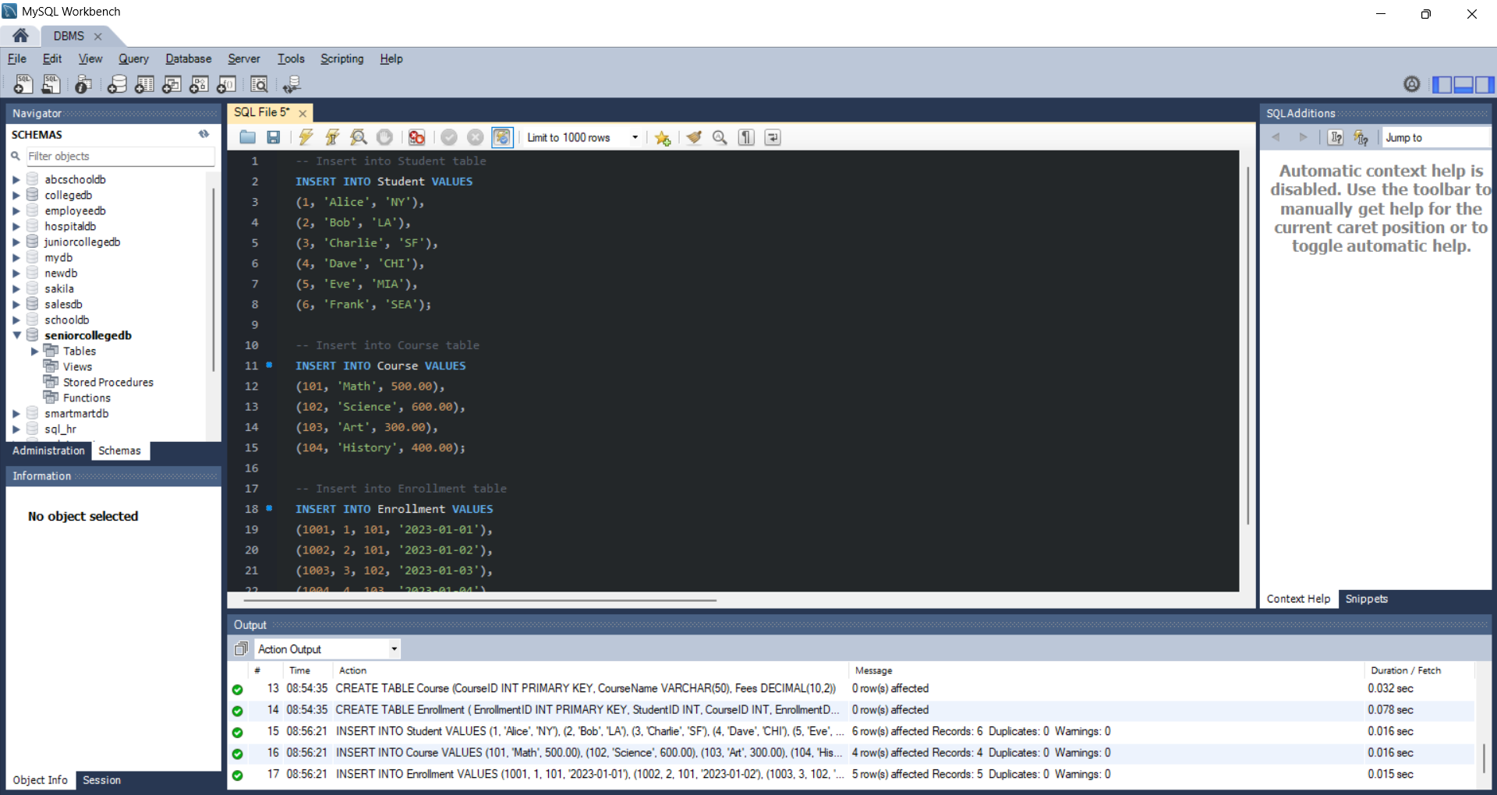

A.3
SELECT student.StudentID,student.StudentName,enrollment.CourseID,enrollment.EnrollmentDate
FROM student
INNER JOIN enrollment ON
student.StudentID = enrollment.StudentID;
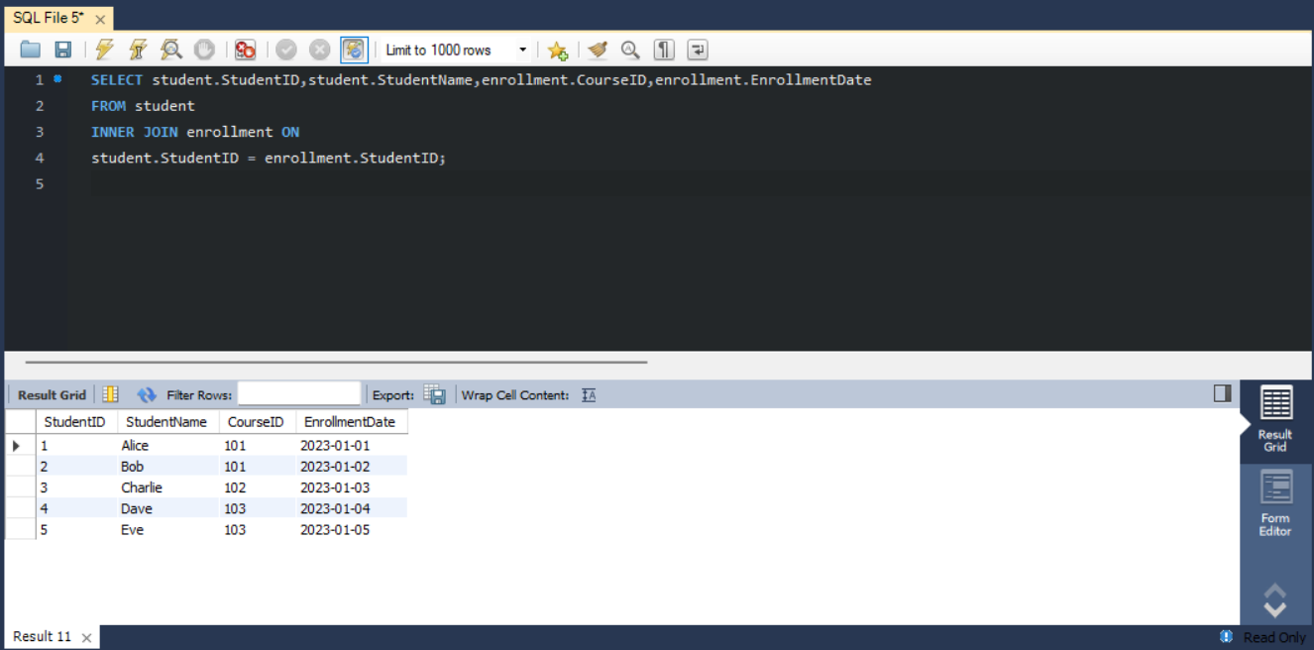

A.4
SELECT Student.StudentName,Student.City,Course.CourseName,Course.Fees,Enrollment.EnrollmentDate
FROM student
JOIN Enrollment ON
Student.StudentID = Enrollment.StudentID
JOIN Course ON Enrollment.CourseID = Course.CourseID;
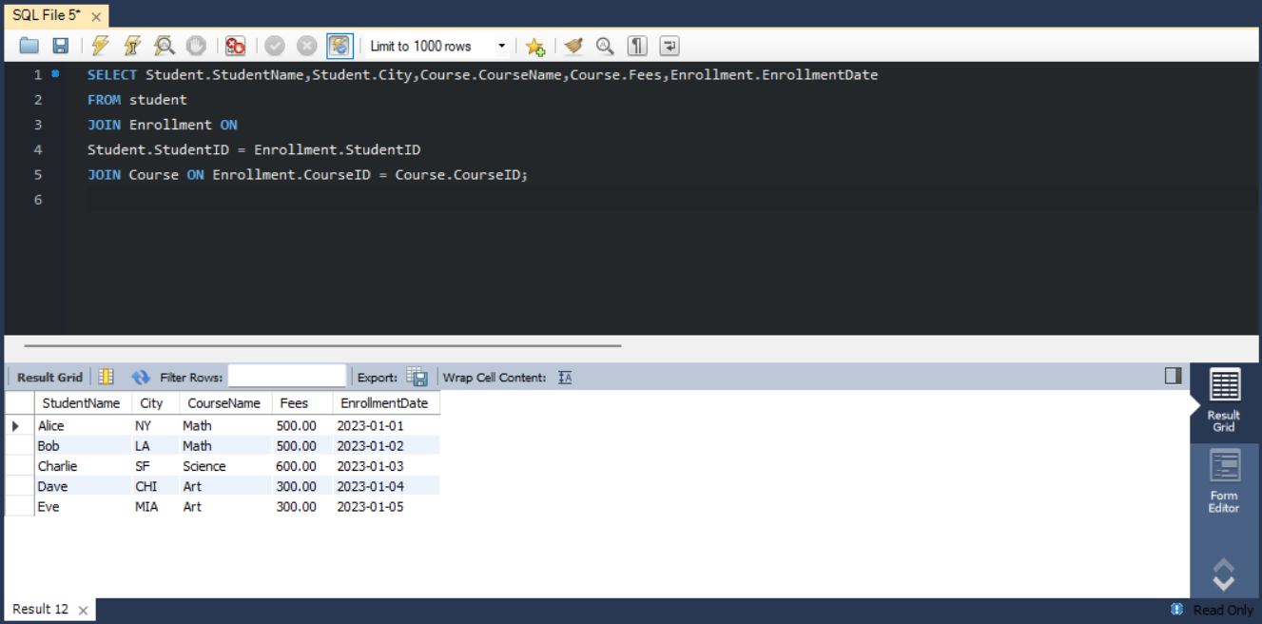

A.5
SELECT Student.StudentID, Student.StudentName, Student.City,Enrollment.CourseID,
Enrollment.EnrollmentDate
FROM Student
LEFT JOIN Enrollment
ON Student.StudentID = Enrollment.StudentID;
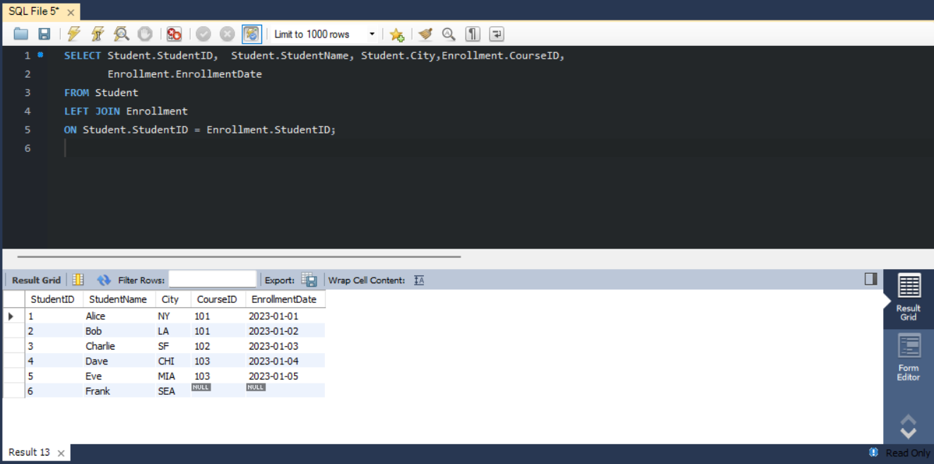

A.6
SELECT Student.StudentName,Course.CourseID, Course.CourseName, Course.Fees
FROM Student
JOIN Enrollment ON
Student.StudentID = Enrollment.StudentID
RIGHT JOIN Course ON
Enrollment.CourseID = Course.CourseID;
